**Letters and Number Practice**

It is so important that our preschoolers practice writing with lots of different materials and utensils. To set up the center, place a set of alphabet flash cards (as a model) next to shallow trays of salt. The students could choose to use a paint brush or a popsicle stick, even a q-tip to write. The sound and feel of the salt on the trays is fun, so in addition to writing letters, you can also do shapes and number as well as spend time touching it. The other thing that I like about these is that they are very easy to clean.

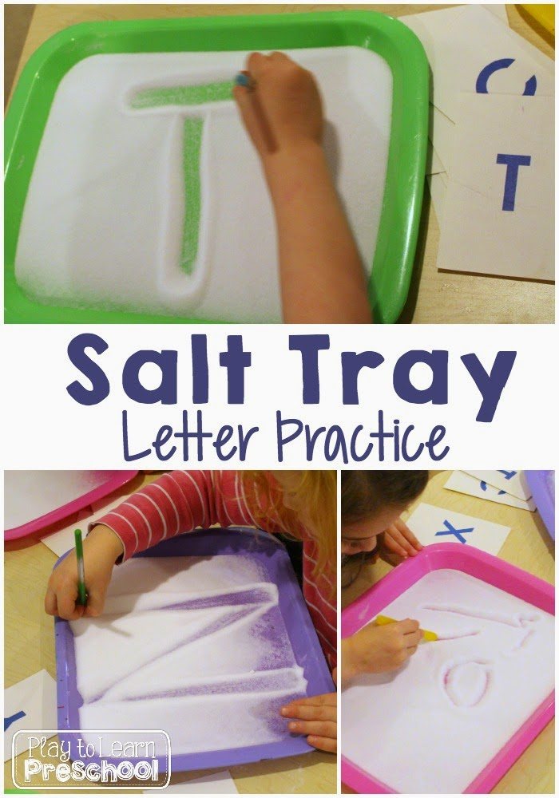

What’s the fastest way to melt ice?

Okay, so I admit that I was curious about this one! Why do cities dump salt and sand instead of…oh, let’s say…sugar? Cost benefits aside, I honestly didn’t know what melted ice faster.

So set up four plates of ice.

And added sand, salt, sugar, or warm water to each plate. Record which one melts faster.

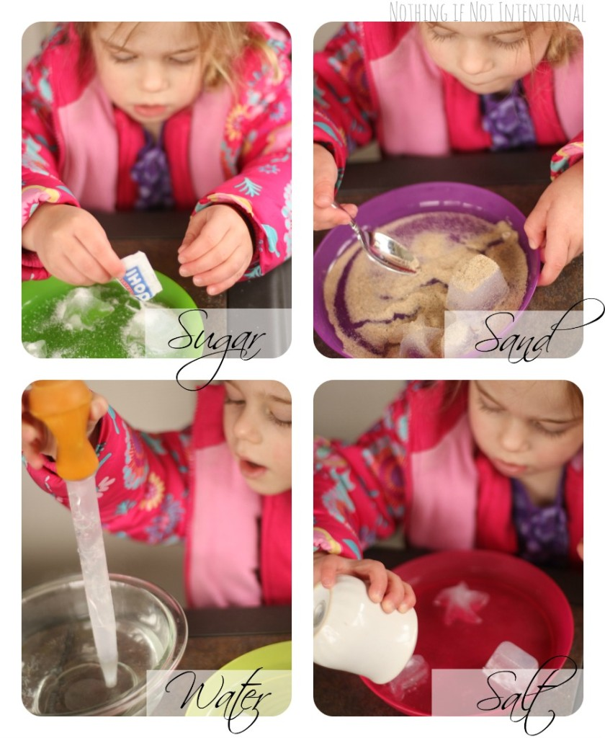

# **How to Make a Rainstick Instrument**

### **Materials for Homemade Rainstick**

* Sturdy cardboard tube (You can use the empty cardboard tube from an aluminum foil roll.)
* Paint (If available)
* Large, brown paper grocery bag
* Yarn
* Rubberbands
* Scissors
* Beads, rice, beans, or other material for inside the rainstick

<https://buggyandbuddy.com/how-to-make-a-rainstick-instrument/>

Clouds in a Jar

**Cloud in-a-Jar**

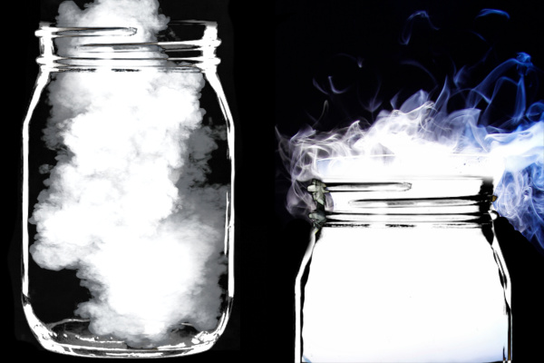**Materials**

* A glass jar
* Boiling water
* Ice
* Hairspray
* A jar-lid or paper plate

Begin by filling a jar 1-2 inches of the way with **boiling water**

* **Carefully** swirl the water inside of the jar to heat the sides of the glass.
* Then, place the lid upside-down on top of the jar.  If you don't have the lid to the jar you can use a paper plate.
* Fill the lid with ice.
* Allow the ice to sit on top of the jar for a minute or two.
* You will have to **be quick with this next part**, so be ready.
* After a minute **quickly** lift the lid of ice from the jar and spray a bit of hairspray into the jar.
* Then, ***quickly place the lid of ice back*** onto the jar.

You will immediately begin to notice **a cloud forming in the jar!**

* And within a few moments **the entire jar will be a cloud!**
* Observe the cloud in the jar for a minute or two.
* Then, when you are ready you can release it!

Water and Soap experiment

### C:\Users\MICHALSTON\AppData\Local\Microsoft\Windows\INetCache\Content.MSO\195C44DB.tmp **Materials:**

* Shallow bowl or pie tin
* Water
* Pepper
* Dish soap
* Toothpick
* Paper
* Pencil

### **Procedure:**

1. Fill the bowl or pie tin with about an inch of water.
2. Sprinkle pepper evenly across the surface. Try not to sneeze! The pepper flakes should float, not sink, upon the surface of the water.
3. Squeeze a tiny bubble of dish soap onto a clean counter.
4. Touch the tip of the toothpick to the bubble of dish soap. You'll want just a tiny amount of soap on the end of the toothpick.
5. Set the toothpick carefully aside and pick up your notebook and pencil.
6. What do you think will happen when you touch your soapy toothpick to the water? How will the pepper flakes react?
7. Write down your best, often called a **hypothesis**, in your notebook.
8. Now poke the soapy toothpick into the water, right in the center of the tin.
9. What happens? Was your hypothesis correct?

**Identifying Colors**

**Have your child look around the house and identify what items are red then have them pick a red item and draw it. (Do this for yellow, blue, green, orange, and purple.)**

**Practicing our numbers (0-5, and 0-10)**

**Take an empty egg carton write numeral 0-10.**

**Have your child put the number of items pertaining to the number in the carton. For example- 5 put 5 beans in the carton.**

